The following have been identified as significant environmental aspects for the site:  These aspects shall be managed with the environmental protection measures outlined on this plan.  Management | Minor Construction Management Plan – Site Setout and Construction Protection Measures  Project Name:  Date and Revision:
1. Responsibilities:  Emergency Contact 1: Name – Mobile – Email  Emergency Contact 2: Name – Mobile – Email | Approved Drainage Plan Placed Here  Legend: Ex Fence Temp Fence Gate Waste Toilet  Site Shed Sediment Trap TPZ Area Contractor Parking  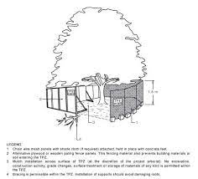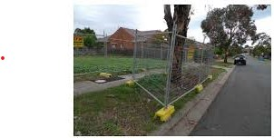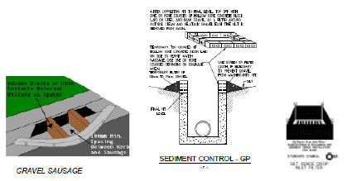
2. Communication of CMP Requirements: A Copy of the CMP to be kept onsite at all times & made available to all contractors.
Site inspections will be undertaken weekly & after rain event/s to ensure adherence to all items in the CMP.

Noise Risk: Significant / Med / Low

Requirement: EPA Victoria and Council requirements must be adhered to in relation to the level of noise and working hours, to ensure that residents and other applicable neighbors to the site are not disturbed unreasonably. The generation of noise must be minimized.
3. Working Hours: 7am to 5pm Monday – Friday - 9am to 1pm Saturday

- Dust Risk: Significant / Med / Low
Requirement: Dust generation must be minimized to ensure there is no health risk or loss of amenity and prevented on dry, windy days.
4. Minimizing Dust Generation: Minimize stripping of soil on hot, dry, windy days. Restrict vehicle movements onsite.

5. Dust Suppression: Dust suppression will also be controlled by means of water, using sprinkler/s or handheld
hose/s with a trigger nozzle. Any debris deposited by vehicles on roads is to be minimized when vehicles are leaving the site and council roads/footpaths are to be kept clean and maintained to the satisfaction of council officers.

Erosion and Sediment Risk: Significant / Med / Low
Requirement: Erosion and sediment must be managed in accordance with current best practice environmental management practices, to prevent sediment-laden water from entering any drainage system or natural waterway. Mud must not be transported on to nearby roads.
6. Drainage Management Outfall drain to be installed prior to internal drainage works.
Debris deposited by vehicles on the road is to be minimized when vehicles are leaving the site and kept clean and maintained to the satisfaction of Council Officers.

7. Sediment Traps: Sediment traps to be placed on All Internal Drainage Pit/s & Council Pit/s.

8. Vehicle and Road Management. Roads must be kept clean, to satisfaction of Council, at all times. Use only nominated access points.
Site Access: Vehicle movements to & from the site & deliveries will only occur during the approved working hours.

Cleaning Vehicles: Vehicles are to be inspected & cleaned of debris by scraping with a shovel & broom before
leaving the site.

Street Cleaning: Any material deposited on roadway to be swept up by means of shovel & broom or use of a street sweeper. Or as directed by an Authorized Council Officer.
Using Street Sweeper as required and or any urgent cleaning may be undertaken by Council’s contractor and the cost of this will be subtracted from the bond”.

Waste Risk: Significant / Med / Low
Requirement: Requirement: Litter and waste must be contained on site, before disposal in a responsible manner. Skip bins must have hinged lids and be kept closed each night and on wind affected days.
9. Waste Storage and Disposal:
All rubbish bin/s and skip bin/s will have lids or be covered to contain airborne material/s.
All timber and metalworks to be recycled where possible.

Chemicals Risk: Significant / Med / Low
Requirement: Storage and spill management practices must be implemented to ensure that no environmental damage can result from the escape or spillage of chemicals or fuels. | Other Site-Specific Issues
10. Storage:  11: Spill Management: | Flora and Fauna Risk: Significant / Med / Low | Archaeological/Heritage Risk: Significant / Med / Low | † Blank 1 Risk: Significant / Med / Low
 | Requirement: All significant flora and fauna on and adjacent to the site must be protected in accordance with AS4970-2009 | Requirement: Places, sites and objects of archaeological or heritage significance must be protected. | 31.
 | 29. Yes / No. Details: Prior to the commencement of any building works  appropriate tree protection fencing must be erected in  accordance with Australian Standard AS4790-2009 & remain  in place until completion of works. | 30. Yes / No. Details:
I have read this Construction Management Plan and agree to undertake works and ensure sub-contractors undertake works in accordance with this plan.
Developer: ______________________ Date: ___________ Contractor: _____________________ Date: ___________

