C
The following have been identified as significant environmental aspects for the site:  These aspects shall be managed with the environmental protection measures outlined on this plan. |  |  | Major Construction Management Plan (1) – Site Setout and Construction Protection Measures  Project Name:  Date and Revision:

Management
1. Responsibilities:  Emergency Contact 1: Name – Mobile – Email  Emergency Contact 2: Name – Mobile – Email |  | 4. Staging of Works: Approximate Months of Construction | Approved Drainage Plan Here  Legend: Ex Fence Temp Fence Gate Waste Toilet  Site Shed Sediment Trap TPZ Area Contractor Parking  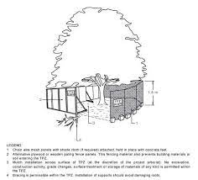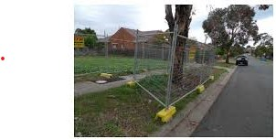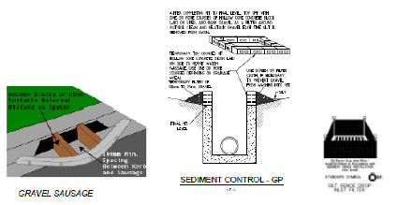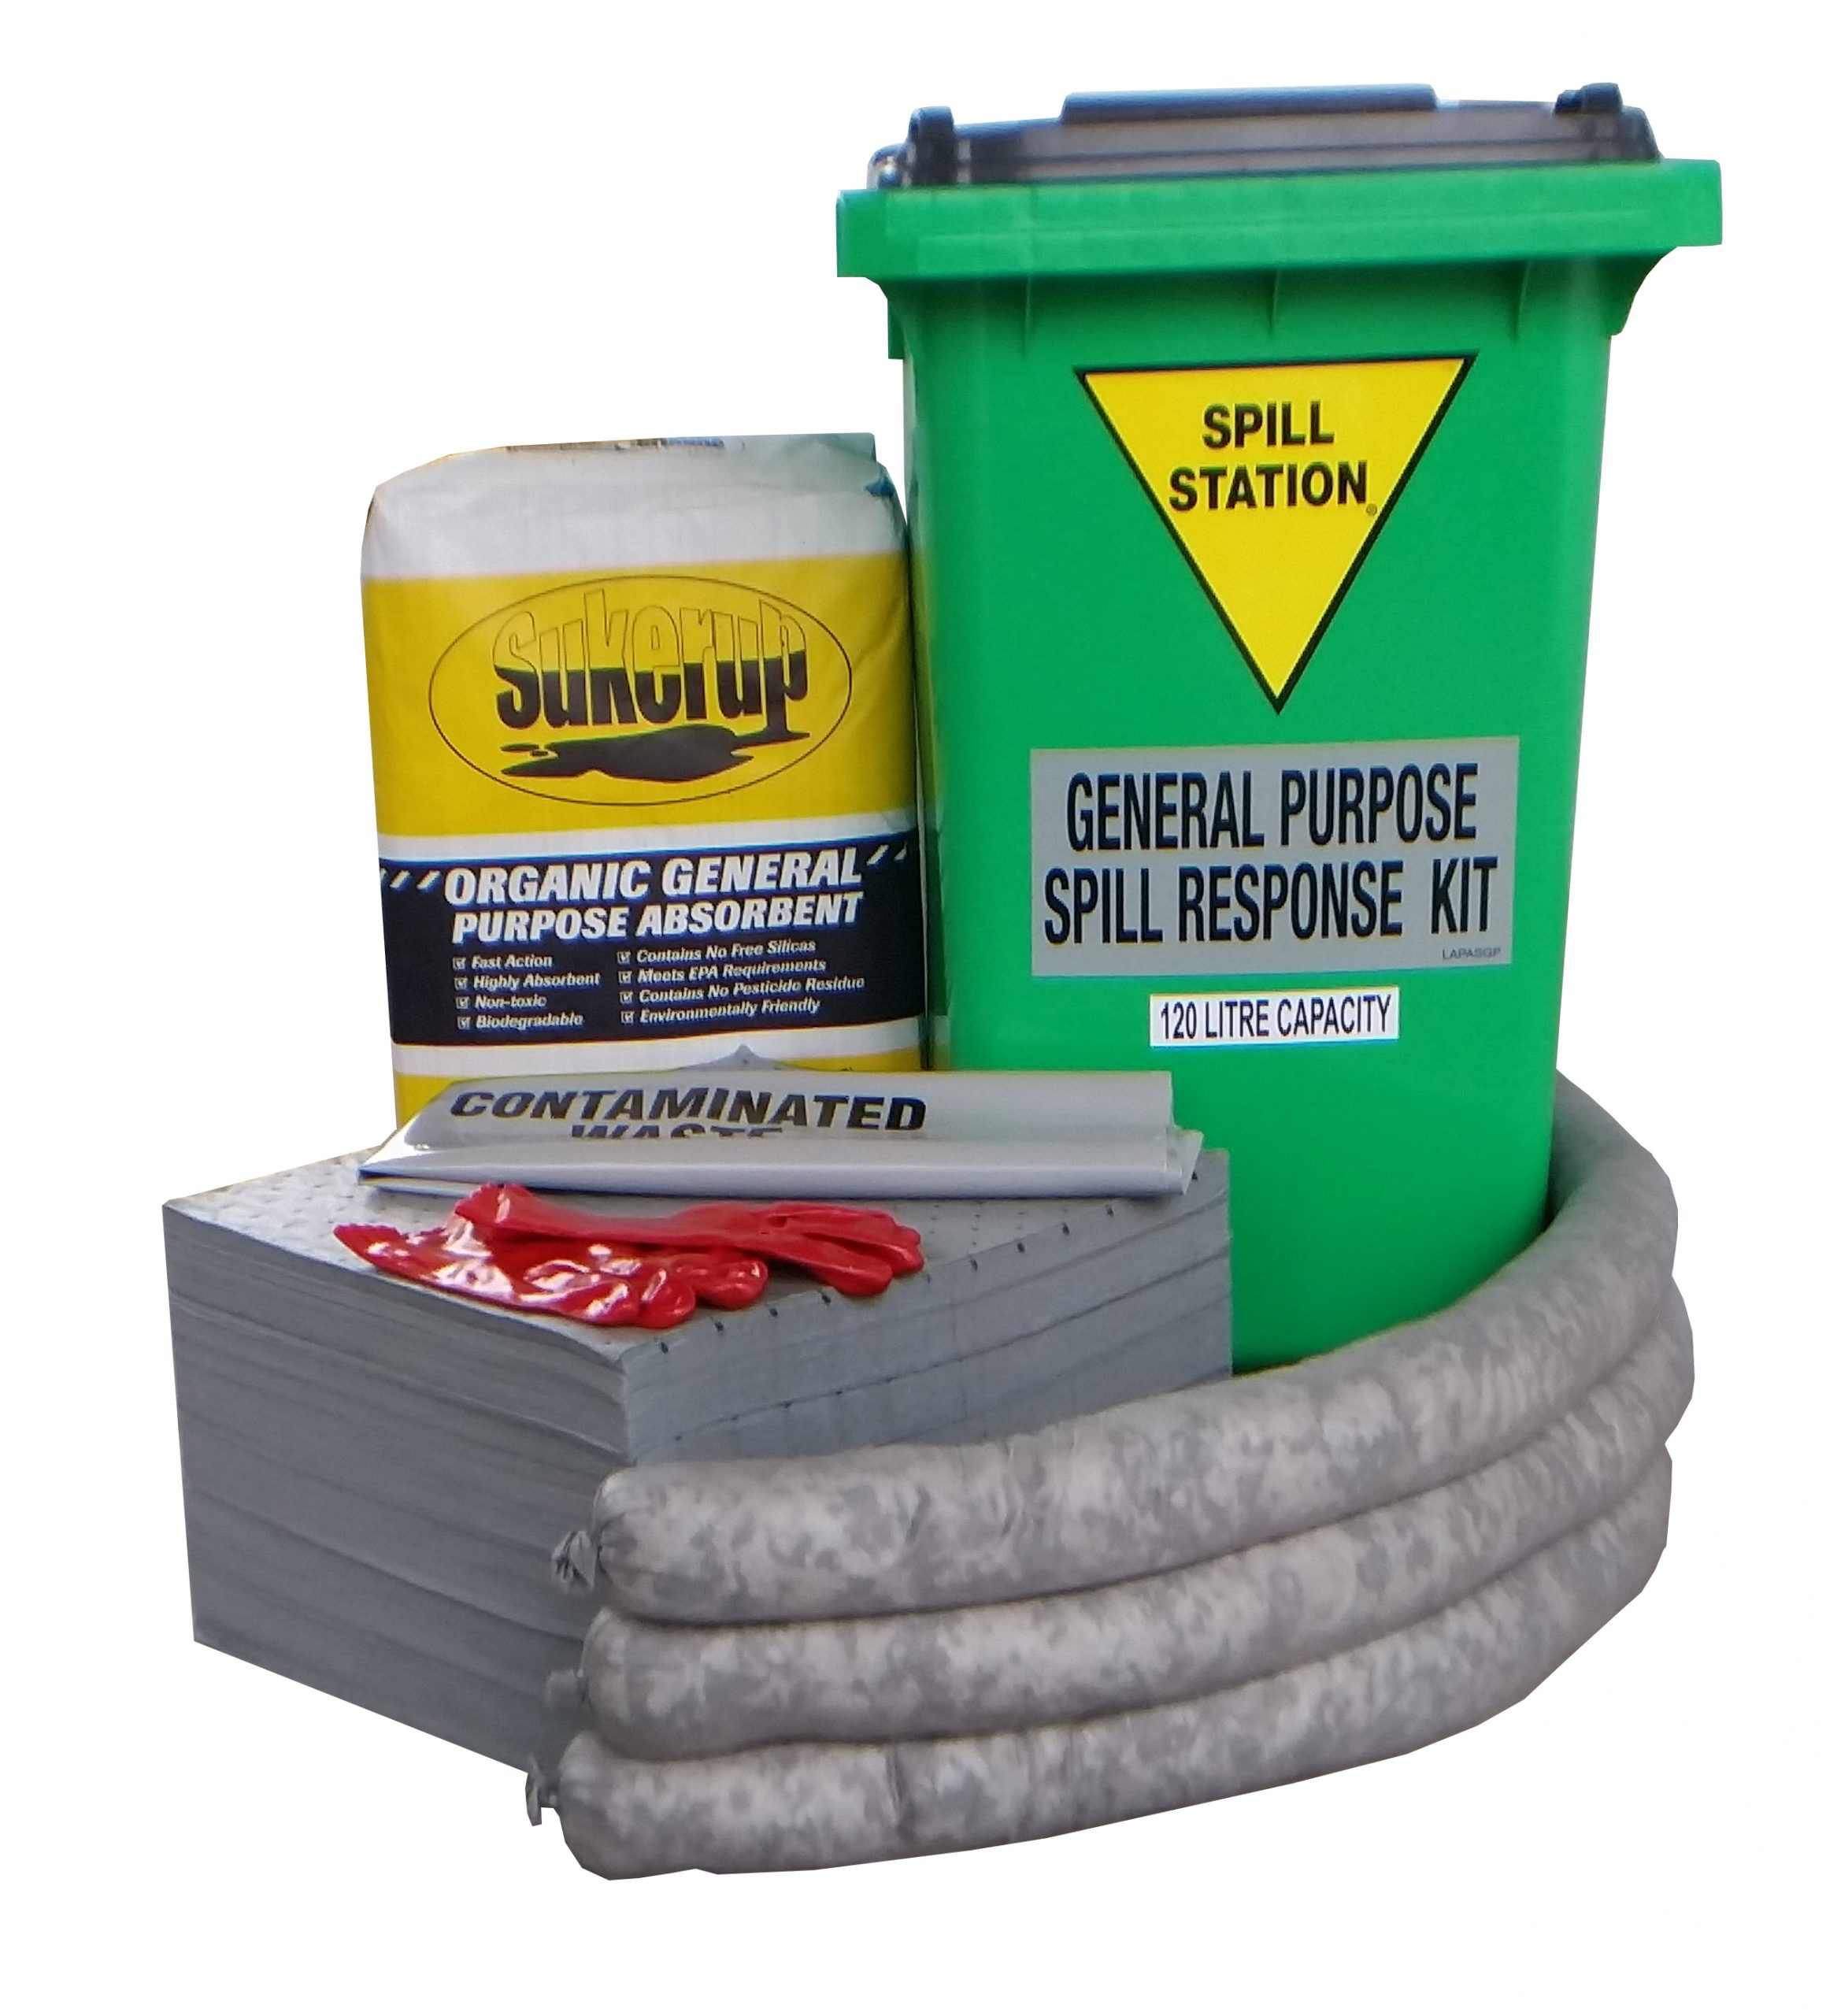
2. Communication of CMP Requirements: A Copy of the CMP to be kept onsite at all times & made available to all contractors. Site inspections will be undertaken weekly & after rain event/s to ensure adherence to all items in the CMP. |  | 5. Informing Residents and Businesses: Nearby residents shall be informed at least two days prior to any construction works via letter drop and door knock.
3. Inspections and Maintenance: |  | 6. Associated Documents: Civil & Architectural Drawings

Noise Risk: Significant / Med / Low

Requirement: EPA Victoria and Council requirements must be adhered to in relation to the level of noise and working hours, to ensure that residents and other applicable neighbors to the site are not disturbed unreasonably. The generation of noise must be minimized.
7. Working Hours:  7 am to 5pm Monday - Friday  9 am to 1pm Saturday | 8. Noise Minimization Methods: | 9. Other:
- Dust Risk: Significant / Med / Low
Requirement: Dust generation must be minimized to ensure there is no health risk or loss of amenity and prevented on dry, windy days.
10. Minimizing Dust Generation: Works on hot, dry, windy days to be minimized to prevent dust. Restrict vehicle movements onsite. |  | 12. Contingencies:
11. Dust Suppression: Dust suppression will be controlled by means of water, using sprinkler/s or handheld hose/s with a trigger nozzle. |  | 13. Other: Any debris deposited by vehicles on roads is to be minimized when vehicles are leaving the site and council roads/footpaths are to be kept clean and maintained to the satisfaction of council officers.

Erosion and Sediment Risk: Significant / Med / Low
Requirement: Erosion and sediment must be managed in accordance with current best practice environmental management practices, to prevent sediment-laden water from entering any drainage system or natural waterway. Mud must not be transported on to nearby roads.
14. Drainage Management: Outfall drain to be installed prior to internal drainage works.  Debris deposited by vehicles on the road is to be minimized when vehicles are leaving the site and kept clean and maintained to the satisfaction of Council Officers. |  | 17. Sediment Traps: Sediment traps to be placed on All Internal Drainage Pit/s & Council Pit/s
 |  | 18. Dewatering:
15. Soil Stabilization:
During Construction:

Post Works:
19. Vehicle and Road Management. Roads must be kept clean, to satisfaction of Council, at all times. Use only nominated access points.
Site Access: Vehicle movements to & from the site & deliveries will only occur during the approved working hours.

Cleaning Vehicles: Vehicles are to be inspected & cleaned of debris by scraping with a shovel & broom before leaving the site.

Street Cleaning: Any material deposited on roadway to be swept up by means of shovel & broom or use of a street sweeper.
Or as directed by an Authorized Council Officer. Using Street Sweeper as required and as directed by Authorized officer, any urgent cleaning may be undertaken by Council’s contractor and
the cost of this will be subtracted from the bond.

16. Stockpile Protection:

 |  | 20. Other:

Waste Risk: Significant / Med / Low
Requirement: Litter and waste must be contained on site, before disposal in a responsible manner. Skip bins must have hinged lids and be kept closed each night and on wind affected days.
21. Movement of Soil: Of- site / On Site / N/A  Contaminant Status: |  | 23. Waste Storage and Disposal: All rubbish bin/s and skip bin/s will have lids o or be covered to contain airborne material/s.  All timber and metalworks to be recycled where possible.
22. Waste Minimization Methods:
 |  | 24. Other:

Chemicals Risk: Significant / Med / Low
Requirement: Storage and spill management practices must be implemented to ensure that no environmental damage can result from the escape or spillage of chemicals or fuels. |  |  | Other Site-Specific Issues
25. Storage: |  | 27. Refueling Procedure: | Flora and Fauna Risk: Significant / Med / Low | Archaeological/Heritage Risk: Significant / Med / Low | Blank 1 Risk: Significant / Med / Low
 |  |  | Requirement: All significant flora and fauna on and adjacent to the site must be protected in accordance  with AS4970-2009 | Requirement: Places, sites and objects of archaeological or heritage significance must be protected. | 31.
 |  |  | 29. Yes / No. Details: Prior to the commencement of any  building works appropriate tree protection fencing must be erected in accordance with Australian Standard AS4790-2009 & remain in place until completion of works. | 30. Yes / No. Details:
26: Spill Management:

 |  | 28. Other:

RISK ASSESSMENT CHECKLIST |  | Major Construction Management Plan (2) - Risk Assessment and Designs of Environmental Protection Measures  Project Name:  Date and Revision:

Noise
Issues:  - Nature of Noise Generating Works:  - Potential Noise Receptors:  - Proximity of Works to Noise Receptors: | Likelihood
 | Consequence
 |  | Environmental protection measures shall be constructed in accordance with the following designs.
 | Overall Risk
- Dust
Issues:  - Dust Sources:  - Potential Dust Receptors:  - Proximity of Works to Dust Receptors:  - Extent of Exposed Earth and Duration of Time Exposed:  - Wind Conditions: | Likelihood
 | Consequence
 | Overall Risk

Erosion and Sediment
Issues:  - Erosion and Sediment Sources:  - Potential Erosion and Sediment Receptors:  - Proximity of Works to Erosion and Sediment Receptors:  - Extent of Exposed Earth and Duration of Time Exposed:  - Soil Type and Erosivity:  - Slope:  - Site Drainage Regime:  - Rainfall:  - Vehicle Movements on and Off Site: | Likelihood
 | Consequence
 | Overall Risk

Waste
Issues:  - Nature of Waste to be Generated:  - Presence of Waste on Site Prior to Work Commencement:  - Quantity of Waste Anticipated:  - Potential Waste Receptors:  - Proximity to Potential Waste Receptors: | Likelihood
 | Consequence
 | Overall Risk

Chemicals
Issues:  - Types of Chemicals and Fuels Used and/or Stored on Site:  - Quantities of Chemicals and Fuels Used and/or Stored on Site:  - Potential Chemical Receptors:  - Proximity to Potential Chemical Receptors: | Likelihood
 | Consequence
 | Overall Risk

Significant Flora/ Fauna
Issues:  - Types of Flora/ Fauna:  - Vulnerability of Flora / Fauna:  - Proximity of Flora/Fauna to Works:  - Work Activities Which May Threaten Flora / Fauna:  - Potential Impacts on Flora / Fauna: | Likelihood
 | Consequence
 | Overall Risk

Archaeological/ Heritage
Issues:  - Traditional Land Owners Consulted? Yes/ No  - Survey or Assessment Conducted? Yes/ No / Not Required  - Probability of Encountering Archaeological/ Heritage Items During Works:  - Types of Archaeological/ Heritage Items on Site:  - Proximity of Archaeological/ Heritage Items to Works on Site:  - Work Activities Which May Threaten Archaeological/ Heritage Items:  - Potential Impacts on Archaeological/ Heritage Items: | Likelihood
 |  | †Blank 1 |  | †Blank 2
 | Consequence | Issues: | Likelihood | Issues: | Likelihood
 |  |  | Consequence |  | Consequence
 | Overall Risk
 |  |  | Overall Risk |  | Overall Risk
I have read this Construction Management Plan and agree to undertake works and ensure sub-contractors undertake works in accordance with this plan.

Developer: ______________________ Date: ___________ Consultant: ______________________ Date: ___________ Contractor: _____________________

