Title: YOUTH STEWARD Volunteers Policy | Version Number: No 1.1
Contact: Coordinator Youth Service | Date to be Reviewed: July 2021
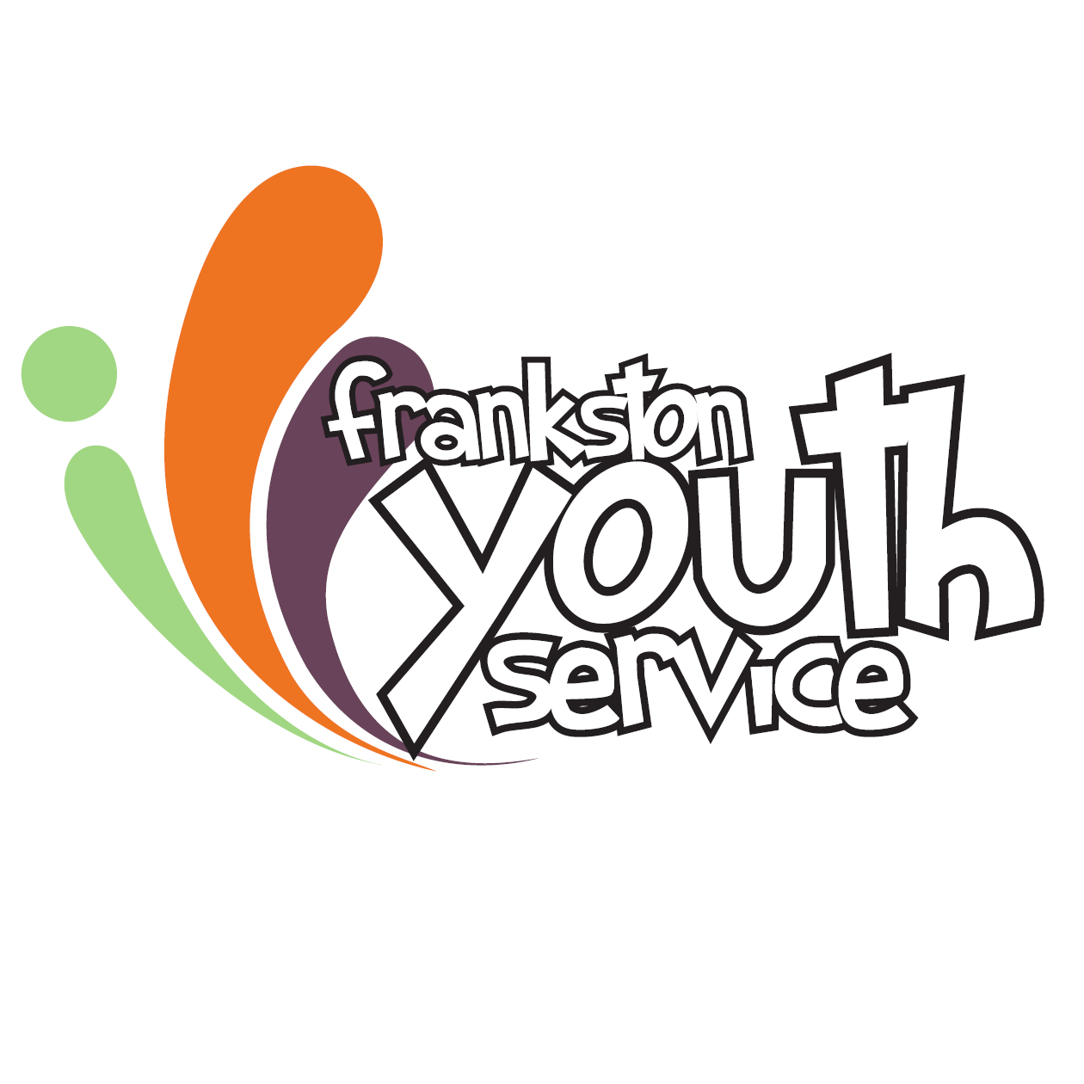

YOUTH STEWARD Volunteer Policy

Purpose

This Youth Steward Volunteers Policy guides the way in which Frankston Youth Service supports the use of youth volunteers.

Objectives

We aim to develop a more inclusive relationship with our youth. We will achieve this by providing opportunities for young people to obtain experience in volunteering and thus contributing to the provision of services for Frankston Youth Service.
Definitions:

- Volunteer opportunities at Frankston Youth Service may exist at Youth Central, Youth Hangout locations, the Youth Bus, during School Holiday Programs, within Fresh Entertainment (FReeZA) and Youth Council, as well as at various events

- A Youth Steward Volunteer refers to a young person who resides in the Frankston LGA and who has Frankston Youth Service’s approval to perform duties for Youth Service without monetary compensation

Position of Youth Steward Volunteers

Youth Steward Volunteers are not employees of Frankston City Council Youth Service and must not, under any circumstance, receive any remuneration of financial or other compensation for their services, or have access to the LAN. Volunteers must under no circumstance have access to any building or be in a building without Frankston Youth Service staff.

Youth Steward Volunteers are not covered by Frankston City Council’s workers’ compensation insurance and Frankston City Council does not provide personal accident insurance for them.

Youth Steward Volunteers will be covered by public liability insurance policies. These do not cover volunteers’ use of their own motor vehicle, which in all cases is undertaken at their own risk.

All Youth Steward Volunteers must be between the ages of 17 years and 21 years.

Appointment of Youth Steward Volunteers

Young people who are interested in becoming a Youth Steward Volunteer must complete a “Youth Steward Volunteer Application Form” and a “Program Registration and Indemnity Form.”
This form is required to be completed and lodged with Youth Central. Following receipt of an application the Coordinator Youth Service will contact a suitable applicant and meet with them to discuss their application. This meeting will discuss Youth Steward Volunteer options and opportunities. Following the meeting, the Coordinator Youth Service will liaise with the Youth Service Team and determine appropriateness for approval. All paperwork must be submitted to the Coordinator Youth Service for personnel records.

The Coordinator Youth Service will notify successful applicants of the result of their application. All applications will be assessed on an individual case basis. Frankston Youth Service reserves the right to accept or decline offers to perform voluntary work.

A probationary period may be required depending upon the task.

If the position involves working with children and the applicant is 18 years or over, a Working with Children’s Check must be provided by the applicant to the Coordinator Youth Service.

Youth Steward Volunteers must adhere to this Policy, and all other relevant Policies and Procedures of Frankston City Council Youth Service at all times.

Volunteers may only undertake work under the supervision and direction of an appropriate Youth Worker.

Failure by a volunteer to comply with this policy, or other applicable Frankston Youth Service policies, may result in Frankston Youth Service terminating the volunteer's engagement.

Frankston Youth Service will endeavour to keep Youth Steward Volunteers informed of matters that affect them.

Frankston Youth Service Statement of commitment to volunteers

Frankston Youth Service will:

- provide effective induction, training, mentoring and coaching

- provide a place which is safe and suitable for the task(s) being performed, and will provide the necessary equipment, and provide training which is appropriate to the task(s) and youth steward volunteer

- provide a clear description of the tasks to be performed

- consult youth steward volunteers on matters that affect them, and provide opportunities for youth steward volunteers to make suggestions

- treat youth steward volunteers professionally and in accordance with organisation policies

Frankston Youth Service’s Statement of expectations of Youth Steward Volunteers

Frankston Youth Service’s expects Youth Steward volunteers to:

- perform tasks which they have agreed to undertake at the appointed time unless negotiated or notified otherwise

- be responsible to the particular area where they are performing their duties but ultimately to the Coordinator Youth Service

- perform all tasks to Frankston Youth Service’s standards or to the satisfaction of the supervisor

- accept and abide by all Frankston Youth Service’s rules and policies

- are not to access the LAN

- behave professionally towards staff, community and other volunteers and generally uphold the Frankston Youth Service’s good standing with the people of Frankston

- refer ALL enquiries to youth workers

Youth Steward Volunteer Terms and Extensions

Youth Steward Volunteer applications are reviewed every twelve (12) months.
A review of applications may result in an extension for a further twelve (12) months.

Conditions

- Before commencing, Youth Steward volunteers will have completed and provided the following:
Youth Steward Volunteer Application Form
Program Registration & Indemnity Form
Youth Steward Volunteer Contract (includes Confidentiality Agreement)
Police check (if applicable)
Driver’s Licence Check (if applicable)
Working with Children’s Check (if applicable)
- Regular attendance times must be organised with the Coordinator Youth Service
- A Youth Steward Volunteer may provide up to 4 hours of assistance in routine tasks each week during school terms and/or participate by agreement as a Youth Steward during school holiday programs
- No remuneration for expenses (i.e. travel) will be provided to Youth Steward Volunteer
- Youth Steward Volunteer must dress neatly when on duty
- Youth Steward Volunteers will be required to wear an identifying volunteer lanyard to signify their voluntary capacity to the community
- Youth Steward Volunteers must sign on and off duty each visit in a log book provided for the purpose. This logbook will include the time commenced and concluded.
- Youth Steward Volunteer must adhere to OH&S requirements to ensure compliance with Frankston City Council OH&S policies and safe work procedures.

Tasks/Duties

Tasks that may be offered to Youth Steward Volunteers include:

- Assist youth workers with school holiday program events
- Maintaining the servery
- Tidying/cleaning youth space areas
- Assisting with displays and brochure stands
- Collating materials for meetings and events
- Assisting in organising craft supplies and materials
- Assisting with general administration tasks ie: sticking labels on envelopes, sealing envelopes, putting materials in envelopes, laminating, sorting, labelling, tidying resources, etc
- Tasks that assist in the presentation of Youth Service, meetings, events and expos
- Folding brochures and flyers
- Assisting with events
- Checking games for missing parts and damage
- Welcoming young people and ensuring they feel included, safe and able to join in

Tasks that cannot be offered include:
- No use of staff computers and the LAN
- Assisting young people with crisis, referral or trauma
- Requesting young people leave the facility at closing times
- Answering the phone and responding to enquiries

Any duties or projects in addition to those above must have the approval of the Coordinator Youth Service.

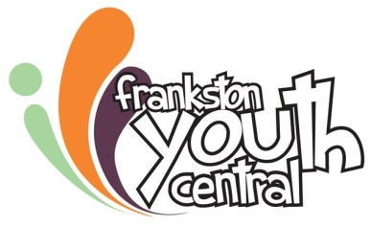
YOUTH STEWARD VOLUNTEER APPLICATION FORM 2020

Name: |  | Date:
Address:

Home Phone: | Your Mobile:
DOB: | Student: YES or NO
School: | Year at school:
Email:

Circle your availability for the following:

School Holiday Program (state which days of the week and times)

Hangouts 3pm-5pm (state which one/s; up to 4 hours maximum per week)

Youth Central (state day/s and time/s; up to 4 hours maximum per week)

Youth Steward Volunteer area of interest:

Your skills/interests:

Do you have any medical conditions that may affect your volunteer capacity? YES / NO

If yes, please specify:

If you are under 18 years of age do you have parental/guardian permission to apply to be a Youth Steward volunteer with Frankston Youth Service? YES / NO

Parent/Guardian declaration:

I have read and understood the content of this document and confirm that the information provided is true and correct. I will take full responsibility to make sure my child’s details our accurate and will notify you of any changes within 14 days.

Signature:

Print Name:

Date:

Person to contact in case of emergency:
Name:

Address:

Relationship:

Telephone: Mobile:

Your declaration:

I have read and understood the content of this document and confirm that the information provided is true and correct. I will take full responsibility to make sure my details our accurate and will notify any changes within 14 days.

Signature:

Print Name:

Date:

YOUTH STEWARD VOLUNTEERING CONTRACT 2020

Each time you are with Frankston Youth Service as a Youth Steward volunteer you will need to
sign in and out.

If you are unable to attend you will need to let the Youth Centre know as soon as possible by
calling 9768 1366.

Youth Steward Volunteers do not have access to staff computers or the LAN.

You are expected to observe appropriate standards of behavior.

Personal details relating to staff and customers are to be treated as confidential and under no
circumstances are to be divulged to the public.

I have read and understood this Agreement and the following document:

Youth Steward Volunteer Policy

Interviewed by: …………………………………………………………………………………..

Future Review Date: ……………………………………………………………………………………..

I agree to abide by all relevant policies and procedures.

.

Name of Youth Steward Volunteer (please print) |  | Signature

Coordinator Youth Service |  | Signature

Date: ………………………………………..
Date:______________________
Date:______________________

YOUTH STEWARD VOLUNTEERING ROSTER 2020

Name:

Roster:

Day | Time | Location/Program
Monday

Tuesday

Wednesday

Thursday

Friday

Staff Name: ………………………………………………………………………………….

Supervisor’s Name: ……………………………………………………………………..

Supervisor’s phone number: ……………………………………………………..

YOUTH STEWARD VOLUNTEER Position Description 2020
THE OBJECTIVE OF THE ROLE:

The objective of the role is to contribute and support the range of services and programs
provided by Frankston Youth Service. Youth Steward Volunteers are expected to
communicate politely, respond to instructions and directions, listen well, be patient,
understanding and respectful of all staff and visitors to the youth centre, with a willingness to be
flexible and enthusiastic.

RESPONSIBILITIES AND DUTIES OF THE ROLE:

Youth Steward Volunteers undertake a range of tasks according to the needs of Youth Service.
Duties include:

Tasks that may be offered to Youth Steward Volunteers include:

- Assist youth workers with school holiday program events
- Maintaining the servery
- Tidying/cleaning youth space areas
- Assisting with displays and brochure stands
- Collating materials for meetings and events
- Assisting in organising craft supplies and materials
- Assisting with general administration tasks ie: sticking labels on envelopes, sealing envelopes, putting materials in envelopes, laminating, sorting, labelling, tidying resources, etc
- Tasks that assist in the presentation of Youth Service, meetings, events and expos
- Folding brochures and flyers
- Assisting with events
- Checking games for missing parts and damage
- Welcoming young people and ensuring they feel included, safe and able to join in

Any duties or projects in addition to those above must have the approval of the Coordinator Youth Service.

THE YOUTH STEWARD VOLUNTEER REPORTS TO:
Youth Steward Volunteers receive direction and supervision from youth workers in accordance with the Frankston Youth Service Youth Steward Volunteers Policy.

REQUIREMENTS OF THE ROLE:

- A completed Youth Steward Volunteer Application Form, Program Registration & Indemnity Form and Contract
- Good communication, organisational and listening skills
- An interest in or knowledge and purpose of the range of services and programs provided by the Frankston Youth Service

